# 4-4- - Conversion table

1. Import conversion table
2. Import the products table from the folder
3. Combine and transform
   1. Sheet 1
4. Select the Transform sample file and rename it Products Sample
5. Then for Assignment 3 rename it Sales
6. Rename this this to Appended Products
7. Products Sample
   1. Delete the Promote to headers
   2. Transform > Transpose:
   3. Home > Merge Queries
   4. First one is Products Sample then the other will be Conversion Table
   5. Select Column1 and Source
   6. Ensure Left Outer Join is selected

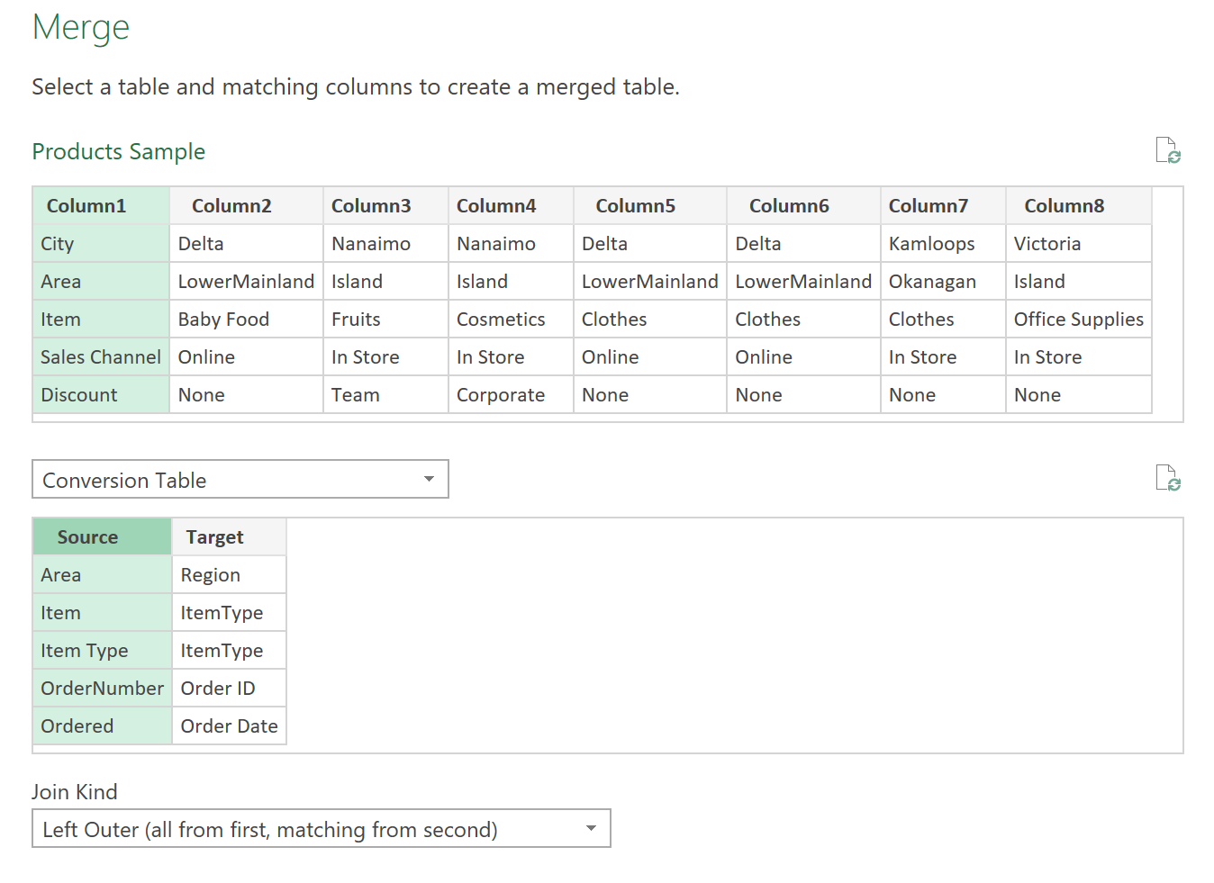

1. Expand the new column
   1. Uncheckmark use original column name as prefix
   2. De- select source
2. Conditional column
   1. Add column > conditional column
   2. Title Is Target

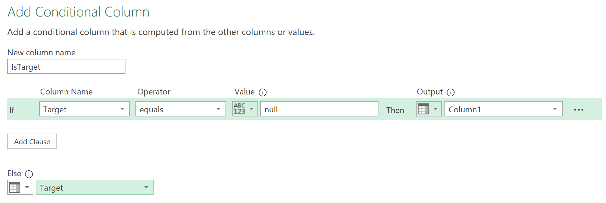

1. Delete the Column1 and Target
2. Transform > Transpose
3. Promote first row as headers
4. Click on the Sales Query now
   1. Remove the Changed Type – this will remove the error
   2. Make sure the right data type for each heading is done
   3. Click order Data column
      1. Data > Year
   4. Select the Payment Data then Order Date then go to Date > Subtract days
      1. Rename this to Duration in Days
   5. Conditional Column
      1. Add Column > Conditional Column

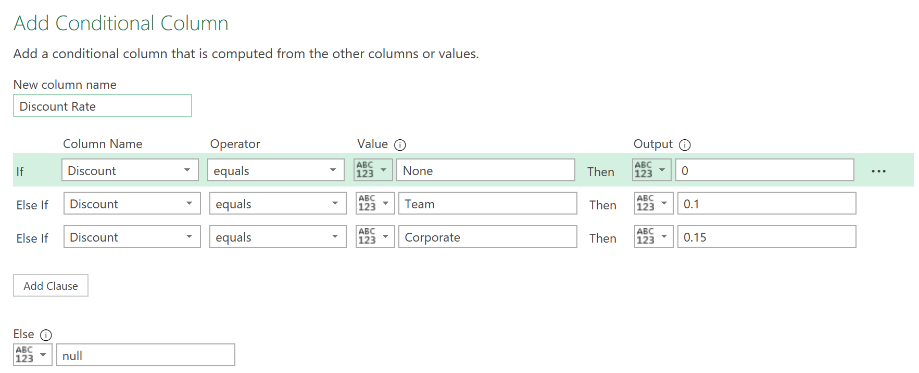

* + 1. Format this as a percentage
  1. Total Sales
     1. Units Sold x Units Price
  2. Total Cost
     1. Units Sold x Units Cost
  3. Total Sales After Disc
     1. Total Sales – (Total Sales x Discount Rate)
  4. Total Profit
     1. Total Sales After Disc – Total Cost
  5. Make sure all data types are set to currency
  6. Remove the Source.Name Column
  7. Close & Load To..
     1. Only Create Connection
     2. Data to Data model

1. Creating Pivot Tables
   1. Table #1
      1. Insert > PivotTable > From Data Model
      2. Add values to fields
      3. Order ID to value but make it a count

You can also add values in the bottom of the Sales chart by adding it in a new cell

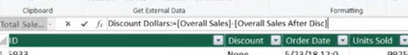

* Then you can reference this function to add to the values you are creating in the PivotTable

